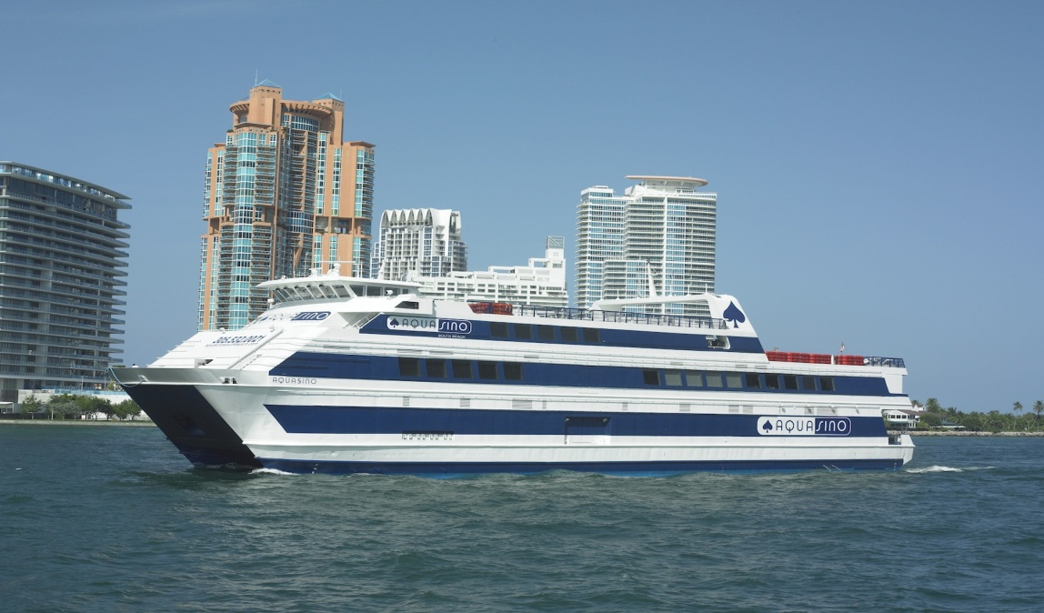

M/V VICTORY II

(ex:ATLANTIC CASINO, MAX I, AQUASINO)
OFFICIAL NO. : 634676
LENGTH : 220’ (overall)
LENGTH : 196.3´ (registered)
BREADTH : 48.0’
DEPTH : 16.0´
DEEP DRAFT : 8.0’
BUILT : 1981 / Underwater Compl. Team, Inc. / New Iberia, LA
REBUILT / LENGTHENED : 1997 / Network Marine, Pierre Part, LA
CLASSIFICATION : None
CERTIFICATION : U.S. passenger vessel, Subchapter K
PROPULSION : Four oil screws; 2,400 total HP
REGULATORY TONNAGE : 97 gross; 66 net
IMO TONNAGE : 3,834 gross; 1150 net
FUEL CAPACITY : 12,800 gallons
SPEED : 10 knots (reported)
